Take-Home Exam 1
Psychology 610
Word Key

Reading Questions:

1. Sum of Squared Errors (SSE) because provides absolute value of errors and weights larger errors more. Also, allows the mean to be the best estimator.

2. Independence: We assume that one error cannot tell us anything about another error. This is easy to see in time series data where on observation will likely behavior similarly to the previous observation; Identically distributed: we assume that all errors are drawn from the same distribution; Errors are unbiased: the mean of distribution form which errors are sampled equals zero.

3. b=0 (because adding that additional parameter does not improve the model fit of C whatsoever)

4.
a. Increase
b. Decrease
c. Decrease
d. Increase

Data Analysis:

5. Figure 1
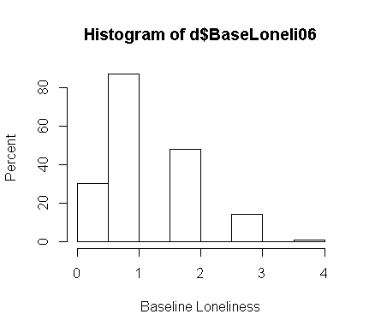
13. Figure 2
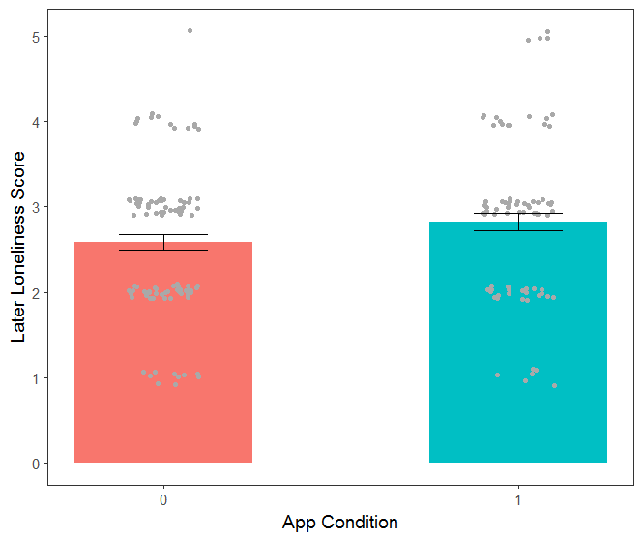

16. Figure 3

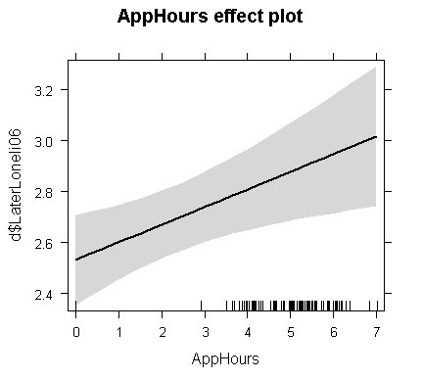
17. Figure 4

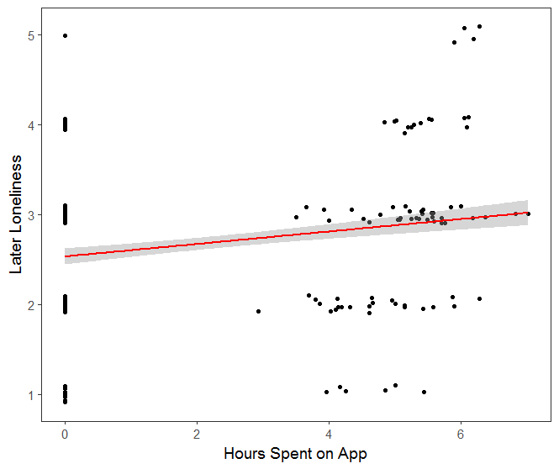

19. Results section:

Researchers tested the effects of a new social media app on user loneliness. 80 heavy social media using student participants were randomly assigned to use the new app every day for a month, while another 100 heavy social media users were assigned to simply continue using whatever apps they normally would for the month of the study. Before assignment to conditions, participants filled out a loneliness questionnaire for which they rated how lonely they generally felt on a scale from 1 (not at all lonely) to 7 (extremely lonely).

After one month, researchers asked the students to fill out the loneliness scale again. Researchers also recorded how many hours a day participants in the Look@ME app condition used the app. The researchers expected the new app to reduce self-reported loneliness.

Prior to analysis, the researchers subtracted 1 from all loneliness scores (i.e., linear transformation) to create a meaningful 0 points. Figure 1 displays the distribution of baseline loneliness scores across the sample. Baseline loneliness scores did not vary between app conditions, b = 0.14, t(178) = 1.10, p = .274.

At post-test, participants displayed a significant (nonzero) amount of loneliness across app groups, b = 2.70, t(178) = 39.53, p < .001. There was no demonstrative evidence that app condition had an effect on loneliness, b = 0.25, t(178) = 1.79, p = .075. App condition only accounted for 2 percent of the variance in the loneliness scores, ${\text{η}}_{\text{p}}^{\text{2}}$ = .02 (see Figure 2). However, in follow up analysis, there was a significant effect of app hours, b = 0.07, t(178) = 2.68, p < .01, indicating that for every hour of app usage, loneliness scores increased by 0.07 units (see Figures 3 and 4). App hours accounted for 4 percent of the variance in loneliness scores, ${\text{η}}_{\text{p}}^{\text{2}}$ = .04.

Despite the researchers’ hypotheses, usage of the new app appeared to increase student loneliness.

