Study1:

8. 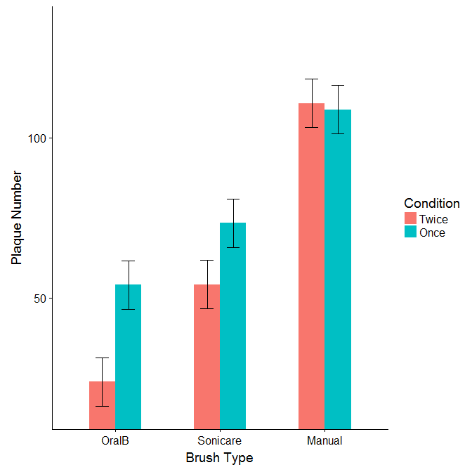Figure 1

9.

In the current study, we assessed the effects of brushing frequency and brush type on brushers’ plaque levels.

We analyzed plaque level in a fully between subjects general linear model with factors for brushing frequency (once a day vs twice a day) and brush type (Oral B, Sonicare, Manual). We analyzed the brush type factor with a set of planned orthogonal contrasts to compare electric toothbrushes (Oral B and Sonicare) to manual and Oral B compared to Sonicare. Consistent with our hypothesis, people who brush once a day on average have 15.83 more plaque particles than people who brush once a day, *t*(42) = 2.56, *p* = .0141, CI = [3.35, 28.31], ${\text{η}}_{\text{p}}^{\text{2}}$ = .14 (see figure 1). Also consistent with our hypothesis, the effect of brushing twice versus once a day was 26.75 units larger for people who use electric toothbrushes compared to people who use manual brushes, *t*(42) = 2.94, *p* = .048, CI = [0.28, 53.22], ${\text{η}}_{\text{p}}^{\text{2}}$ = .09. As predicted, the effect of brushing twice versus once a day was similar for people who used Oral B compared to people who use Sonicare electric toothbrushes, *t*(42) = 0.73, *p* = .472, CI = [-41.57, 19.57], ${\text{η}}_{\text{p}}^{\text{2}}$ = .01.

Our results suggest that people who use electric toothbrushes have significantly less plaque. Furthermore, the benefit of brushing twice versus once a day appears to only hold for those that use electric toothbrushes (vs manual).

Study 2:

8.



Figure 2

9. In the current study, we tested the effects pictures of instructors with different types of facial hair have on smiling in traditional and non-traditional students.

We analyzed facial EMG smiling activity in a separate general linear models each with a between-subjects factor for student group (Traditional vs Non-Traditional) and repeated measures for picture type (John, Mitch, Daniel). We analyzed the picture type factor using pair-wise within subject contrasts to consistent with our research goals. We used Holm-Bonferroni correction on all p values.

Consistent with our hypothesis, the difference in smiling between traditional and non-traditional students was 4.23 microvolts larger when viewing pictures of Daniel than when viewing pictures of John, *t*(117) = 4.23, *p* = .019, CI = [1.06, 7.40], ${\text{η}}_{\text{p}}^{\text{2}}$ = .06 (see figure 2). Furthermore, the difference in smiling between traditional and non-traditional students was 8.25 microvolts larger when viewing pictures of Mitch than when viewing pictures of John, *t*(117) = 3.51, *p* = .002, [3.59, 12.90], ${\text{η}}_{\text{p}}^{\text{2}}$ = .10. Finally, the difference in smiling between traditional and non-traditional students was 4.02 microvolts lower when viewing pictures of Mitch than when viewing pictures of Daniel, *t*(117) = 2.41, *p* = .019, [-7.32, -0.71], ${\text{η}}_{\text{p}}^{\text{2}}$ = .05. Our results suggest that while Mitch’s mustache may be the most liked facial hair in many settings, it may also be the most polarizing between traditional and non-traditional students.