THE2 Word Key

Study 1
A researcher was interested in settling the age-old debate about whether dogs or cats are smarter, so she designed a novel problem-solving task for the pets to test the idea. She also included a learning condition to see whether training would be more beneficial for one type of pet over the other. She hypothesized that cats would show more intelligence overall, evidenced as higher scores on a testing phase with different iterations of her task, but that the learning condition would be more helpful for dogs than cats.
An outlier analysis showed that one cat had undue influence on the parameter estimates. Notes from the experiment showed this cat fell asleep during the testing phase, and thus was excluded from reported analyses.
The data confirmed the researcher’s first hypothesis: cats correctly completed about 5 trials more than dogs, averaging across conditions, b = 5.41, [2.76, 8.07], t(102) = 4.05, p < .01, $η_{p}^{2}$= .138. There was also a significant interaction, indicating that the difference in scores across training conditions is greater for dogs than for cats: this shows the training was more useful for dogs (see Figure 1), b = -7.84, [-13.15, -2.54], t(102) = -2.93, p < .01, $η_{p}^{2}$= .078. In fact, the training eliminated the performance gap between cats and dogs, t(102) = 0.79, p = .43.
While cats might be smarter than dogs overall, this research shows that with a little help, dogs can perform just as well as cats on a novel intelligence task.

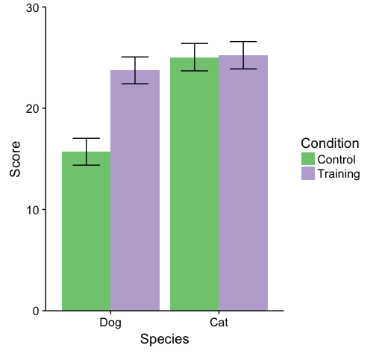
Figure 1

Study 2
A grad student embarked on a mission to peg down the science of an amazing pie. He made many pumpkin pies with a range of alterations to better understand how a pie’s component elements contribute to its taste. He recruited renown cookery writer Mary Berry to judge the pies. He expected including more fat in the crust would improve the pie’s taste, but only if the pie did not have a “soggy bottom.” He further predicted that spice would positively affect taste, and this effect would be stronger for pies with a higher ratio of sweetened condensed milk to canned pumpkin.
The models by and large satisfied the criteria of model assumptions. Some slight deviations were observed, likely owing to a negative skew in Mary Berry’s ratings, but with a suggested transformation of only 1.47, we opted to keep the variables as-is (especially since most have clear, objective interpretations).
With regard to the first hypothesis, there was a main effect showing fattier crusts obtained higher ratings, averaging across pies with and without soggy bottoms, b = 0.13, [.07, .20], t(124) = 4.02, p < .001, $η_{p}^{2}$= .12. There was also a significant interaction, indicating that the effect of amount of fat used was more positive for pies that did not have a soggy bottom (see Figure 2), b = -0.14, [-0.27, -0.02], t(124) = -2.21, p < .05, $η_{p}^{2}$= .04. Indeed, as predicted, there was no effect of fat for pies that had a soggy bottom, t(124) = 1.11, p = .27.
To obtain the ratio of sweetened condensed milk (SCM) to canned pumpkin, we took the difference between the quantities (their sum was constant at 32oz). An interactive model between this variable and amount of spice used showed a marginal positive effect of spice for pies with an average balance of SCM to canned pumpkin, t(124) = 1.9, p = .06. The interaction term was significant, however, confirming the prediction that the effect of spice would be stronger for pies heavier in SCM relative to canned pumpkin (see Figure 3), b = -0.05, [-0.08, -0.02], t(124) = -2.94, p < .01, $η_{p}^{2}$= .065.
This research provides valuable information about what makes for a good pumpkin pie. It remains unclear whether these principles will apply similarly to other types of pie or judges other than Mary Berry. Further research, and many more pies, should seek to answer these outstanding questions.
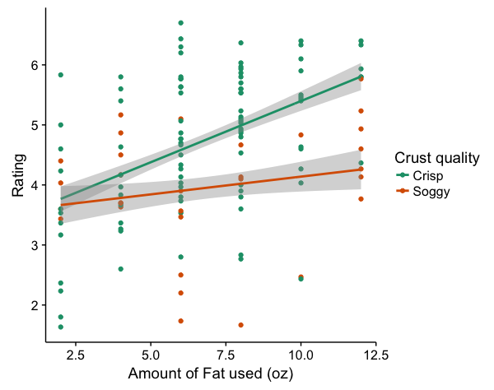
Figure 2
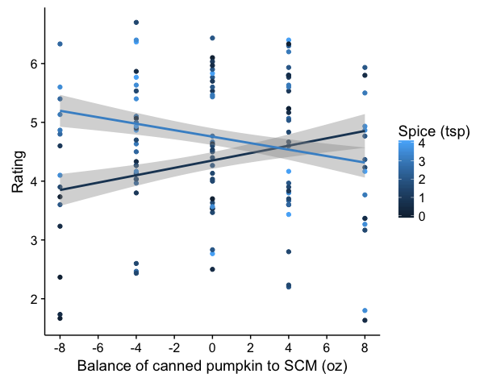
Figure 3

