Homework 9 Results Section

We were interested in the factors that affect a student’s well-being over the Thanksgiving holiday. Specifically, we wondered whether the topic of conversation at the dinner table predicted student well-being.
First, we assessed the effect of time spent talking about the student’s relationship status. We expected more time spent on this topic would predict lower subjective well-being, but this effect would differ based on how long the student had been in a relationship themselves. Specifically, we hypothesized the negative effect of time spent on this topic would be stronger the shorter the student’s relationship was. For people with relationships of average length, there was no significant effect of time spent talking about relationships, t(180) = -1.34, p = .18, ${\text{η}}_{\text{p}}^{\text{2}}$ = .01. There was, however, a significant interaction supporting our hypothesis, b = 0.0065, [0.004, 0.009], t(180) = 4.87, p < .001, ${\text{η}}_{\text{p}}^{\text{2}}$ = .12. These results are displayed in Figure 1, with lines plotted for students not in a relationship (relationship length = 0) and those in a long relationship (M + sd relationship length).
We were also interested in the role of time spent talking about politics. Like student relationship, we imagined this topic would have a negative effect on subjective well-being, but this too would be qualified by a significant interaction. We took the absolute value of the number of conservatives at the meal less the number of liberals at the meal, serving as a rough measure of polarity (where smaller scores indicate more division within a family, M = 4.03, range = 0, 12). We expected the effect of time spent talking politics would be more negative for more ideologically divided families (i.e., polarity closer to 0). For students with average familial polarity, there was a negative effect of time spent talking politics, b = -0.025, [-0.031, -0.019], t(180) = -7.93, p < .001, ${\text{η}}_{\text{p}}^{\text{2}}$ = .26. This effect was qualified by a significant interaction confirming our hypothesis, b = 0.0027, [0.0004, 0.005], t(180) = 2.30, p < .05, ${\text{η}}_{\text{p}}^{\text{2}}$ = .03. Figure 2 displays the results of these analyses, with lines plotted for relatively divided and relatively similar families (i.e., ±1 sd around mean polarity).
Based on these results, we suggest students try to steer their families away from these conversation topics when they’re home for the holidays, particularly if they are single or their family is politically divided. They might instead try to find a more neutral or even affiliative topic, such as football or how much everyone likes Tom Hanks.

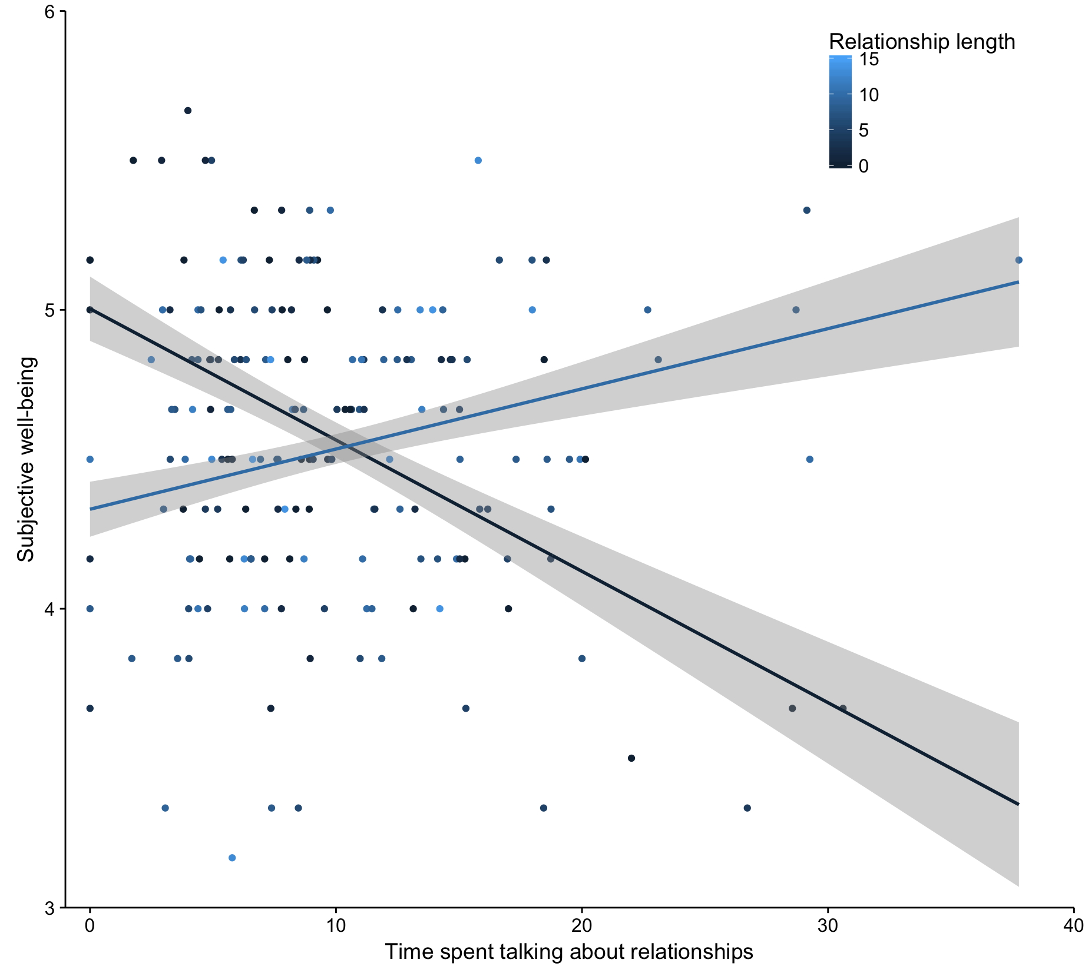
Figure 1

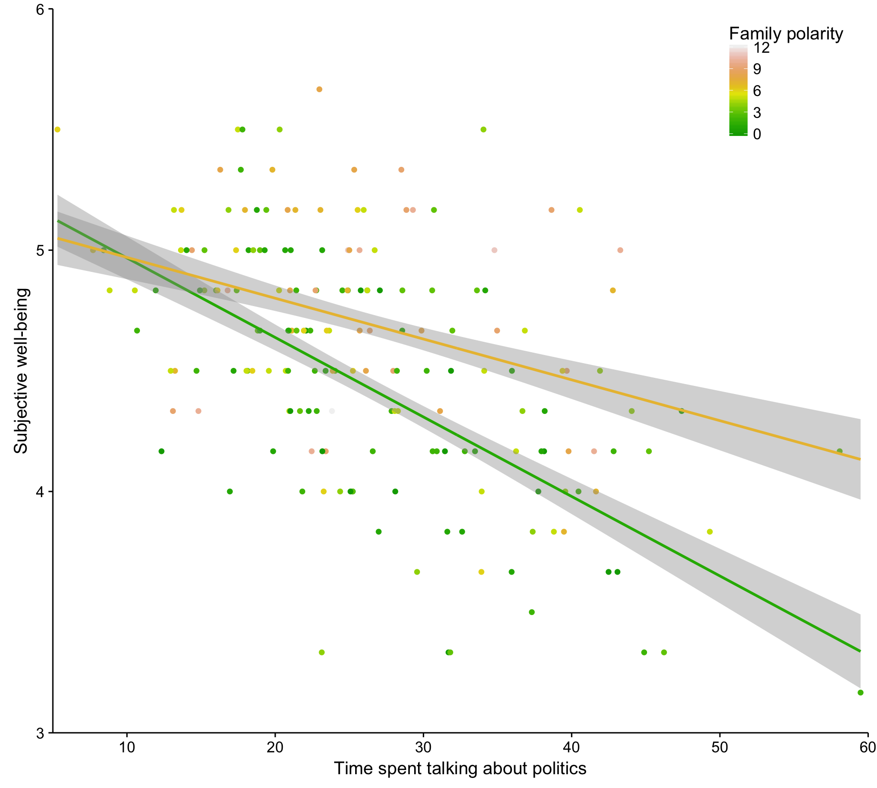
Figure 2

