**Homework 3 Word key**

**2a.**

**dogs and shelters.pdf**

**5.**

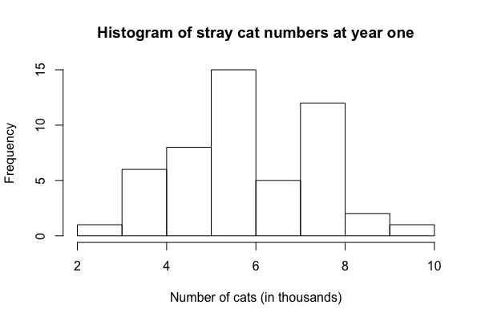

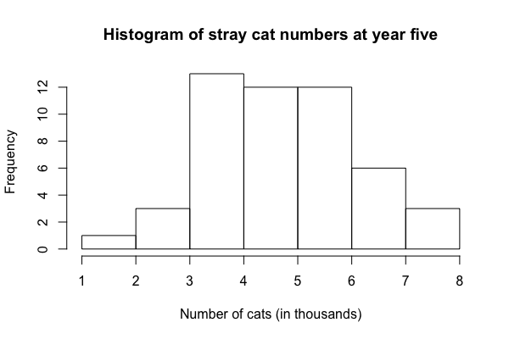

12. In this example, our errors are not independent of one another, because cats in a given household are likely to eat much more similar amounts of food than any pair of cats chosen at random. One possible fix is only considering consumption of one cat within each household.

13. Type I error is the probability of rejecting null hypothesis when null hypothesis is true. We can decrease our chance of making this error by decreasing our alpha value (e.g., to .01 instead of .05).

Type II error is the probability of failing to reject the null hypothesis when null hypothesis is false. We can decrease our chance of making this error by adding more participants, having more extreme experimental treatments, controlling for more covariates, and more.

14. The numerator of *F* represents how much variance is explained / how much error is reduced by each one of all additional parameters that augmented model included (besides the parameters included in compact model), on average.

The denominator of *F* represents how much “leftover” variance (unexplained by the augmented model) is expected to be explained by every additional parameter that could be estimated (not included in the augmented model), on average. In other words, the average prediction error.