Homework 10 Key

Reading questions

1. Judd and colleagues (2017) argue that the term “main effect” is usually applied incorrectly when interpreting regression coefficients from interactive models. They note that while this term is meant to convey the idea that a variable has an effect across all levels of another variable, that isn’t actually what the test of a single parameter demonstrates. Rather, in an interactive model with centered variables, a coefficient for a given parameter represents the effect of that variable for a specific kind of participant: one who is average with regard to the other predictor variable(s). Thus, they argue that the term “simple effect” should be used in these situations, just as it is when we examine effects at specific levels of the predictor variables. Jaccard & Turrisi (2003) take a similar perspective as Judd and colleagues.

2. bilinear interaction.

3. Researchers frequently misinterpret regression coefficients associated with predictor variables that are components of interactions.

Data analysis
2.

Experimental Condition | Past Experience | Game Score
Placebo | Novice | 96.2 (10.4)
 | Experienced | 77.5 (13.4)
Alcohol | Novice | 63.5 (34.7)
 | Experienced | 85.1 (36.4)

4e.
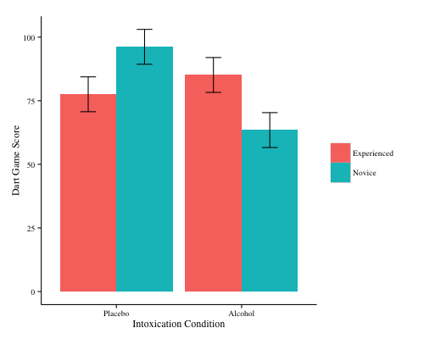
Figure 1: Game performance as a function of condition and experience.
5d.
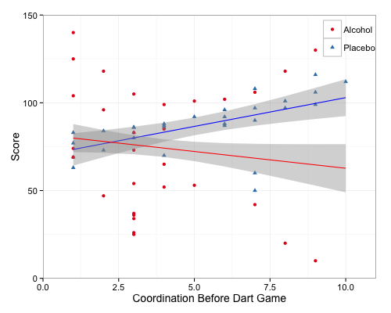
Figure 2: The effect of coordination, condition, and their interaction on game performance. Effect of condition becomes larger at higher self-reported levels of coordination.

6.
Can the fine motor control needed to be successful in a darts game be affected not only by alcohol, but also by the expectation of alcohol’s effects? We tested whether the placebo effect could explain participants' scores on a dart game: participants consumed either alcoholic or convincing non-alcoholic drinks. Participants self-reported their experience playing darts and their coordination abilities. Our central hypothesis was that there would be an interaction between experience playing darts and condition, with more experienced players being less affected by the alcohol.
There was no main effect of alcohol condition, t(56) = -1.83, p = .07, CI = [-26.3, 1.17], ${\text{η}}_{\text{p}}^{\text{2}}$= .06. Our central hypothesis was confirmed, with the interaction between condition and experience reaching statistical significance, t(56) = 2.94, p = .004, CI = [12.87, 67.80], ${\text{η}}_{\text{p}}^{\text{2}}$= .13 (see Figure 1). Analysis of the simple effects of experience showed that among those in the alcohol group, experienced players scored 22 points better in the darts game, on average, than the novices, t(56) = 2.24, p = .029, CI = [2.25, 41.1], ${\text{η}}_{\text{p}}^{\text{2}}$= .08. Among those in the placebo group, experienced players scored 13 points worse in the darts game, on average, than the novices, but this effect was not significant, t(56) = 1.93, p = .059, CI = [-38.1, 0.7], ${\text{η}}_{\text{p}}^{\text{2}}$= .06.
We decided to perform some additional analyses for exploratory purposes. We tested whether coordination also interacts with condition to predict darts scores. The interaction between the variables was marginal but not significant, t(56) = -1.84, p = .071, CI = [-10.8, .46], ${\text{η}}_{\text{p}}^{\text{2}}$= .06 (see Figure 2). Exploratory analysis showed that the condition effect appeared to be stronger for those with higher coordination: for example, participants with a coordination score of 8 scored almost 30 points worse in the alcohol condition than in the placebo condition, t(56) = 2.41, p = .019, CI = [-54.7, -5.0], ${\text{η}}_{\text{p}}^{\text{2}}$= .09
Overall, these results suggest that the effect of taking a placebo cannot be considered to be equivalent to consuming alcohol, when considering other important factors including coordination and expertise. Future research should further clarify these relationships.

